Slam Game Design Document
By Kayne Ruse

Last Updated 2/4/2012
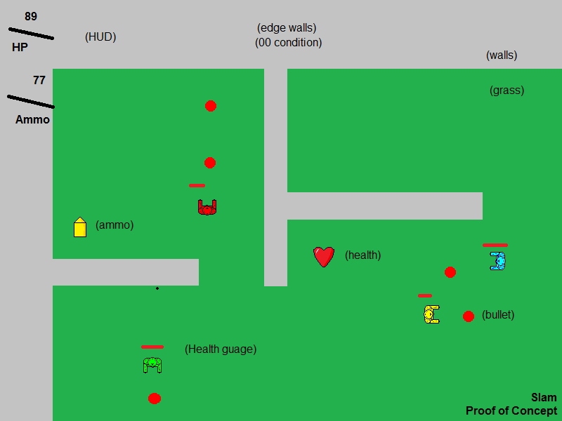

Introduction 3
Marketing info 3
Gallery 3
Story 4
Game Mechanics 4
Core Gameplay 4
Player Controls 4
Game Characters 5
Red 5
Blue 5
Green 5
Yellow 5
Bots (bot AI) 6
Personality 1 (aggressive) 6
Personality 2 (defensive) 6
Game World 7
HUD 7
Levels/Maps 7
Tileset 7
Game Objects 8
Characters 8
Bullets 8
Health Pickup 8
Ammo Pickup 8
Sounds 8
Screen Flow 9
Technical details 10
Development Schedule 10
Version 2 10
Post Mortem 10

Introduction
Slam is a multiplayer 2D top down arcade shooting game inspired by Quake Death Match. Players fight against each other over a networked match, trying to gain as many kills as they can before the time runs out. At the end of the match, the player with the highest score wins.

The players must navigate around the game world to collect ammunition and health pickups from specific spawn points. The host of the game can also add bots before the beginning of a match. These AI driven players will fill up a game when there are not enough players to begin. Players must join a match before it begins and if a player loses contact with the server, it is considered a forfeit.

Marketing info
Slam is a top-down 2D multiplayer arcade shooting game, inspired by the movie “Gamer”, aimed at a 13 and older audience. The target platform is the Microsoft Windows OS, with the possibility of porting to Mac and Linux.

Gallery
<GALLERY>

Story
The game takes place inside a colosseum where prisoners on death row fight each other to the death for a chance to walk free. The whole world tunes into this new spectator sport, so the prison wardens demand the best performance from the prisoners, lest pay-per-view profits start to fall.

Game Mechanics

Core Gameplay
When a player spawns (begins the game) or respawns (renters the game after previously running out of health) the player will spawn in the map with a one second “safe” period that they can use to move away from opponents. The player can attack other players while in this safe mode, but cannot be hurt. The player’s all start with the maximum health and ammunition points available. When the player comes into contact with a wall, the player will come to a stop.

The players cannot have more that 100 health points, and 100 ammunition points. If any player gains more than this amount of either resource, than the resource’s value is set back to the maximum. If a player’s ammunition points reach zero, the player cannot fire their weapon; if a player’s health points reach zero, than the player “dies” and respawns on the map with the maximum health and ammunition points available.

Player Controls
This game requires a keyboard and mouse. The player moves around the world using the WASD control setup, moving at a preset speed (roughly 0.14 units, adjusted for the frame rate) in any of the eight possible directions. The character’s sprite rotates to constantly point towards the mouse cursor, allowing the player to aim. Pressing the left mouse button fires a bullet in the direction that the character is facing (towards the mouse cursor).

The WASD control setup details controlling the player’s movement using the W (up), A (down), S (left) and D (right) keys on the keyboard to move in any cardinal direction. If two non-opposing keys are pressed at the same time, the player can move in a diagonal direction.

Game Characters
There will be four characters the players can choose from; their sprites are 32 * 32 pixels.

Red
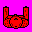
Red is a mercenary, with over a hundred kills under his belt. He sleeps next to a gun, just in case a fellow inmate decides his pillow looks comfortable.

Blue
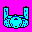
Blue is a common street thug, busted after a bad deal. He volunteered for the coliseum for a shot at freedom.

Green
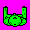
Green is former cop, turned criminal after a run-in with a group of Australian game designers. To this day, he is plotting his revenge.

Yellow
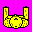
Yellow is a lawyer who got off the elevator on the wrong floor, and was accidentally caught up in the combat of the coliseum. All of the other combatants resent yellow.

Bots (bot AI)
The some behaviour that the bots can execute is:

- Patrol around the map
- Attack another player
- Search for pickups
- Flee from an enemy

The bot AI will be written as “personalities” i.e. aggressive or defensive.

<NOTE:
There is a possibility of adding that the bot can determine its actions according to:
The conditions of the enemy
The number of enemies in sight
The closest/furthest enemy/health/ammo
>

Personality 1 (aggressive)
if (enemy in sight):
if (health < 30): flee the enemy
else if (ammo > 0): attack the enemy
else: search for ammo
else:
if (health < 60): search for health
else if (ammo < 50): search for ammo
else: patrol the map
end

Personality 2 (defensive)
if (enemy in sight):
if (health < 50): flee the enemy
else if (ammo > 0): attack the enemy
else: flee the enemy
else:
if (ammo == 0): search for ammo
else if (health < 50): search for health
else if (ammo < 50): search for ammo
else if (health < 80): search for health
else if (ammo < 80): search for ammo
else patrol the map
end

Game World
The game world is made up of the game map, dictated by the server, and all of the objects in the world. Depending on the size of the game map (usually about 4 times the size of the screen), the game world will be larger than the view port provided by the screen. Therefore, the camera will follow the player’s avatar as it moves around the world.

HUD
The HUD will consist of a health count, an ammo count, and a timer counting down until the end of the match. To help players, each in game enemy character will have a small health gauge floating above their head.

Levels/Maps
The maps are loaded from text files, created by the simple map editor. The host of the server can choose the specific map before the game starts, however each client connecting to the server must have a copy of the map. The spawn points of the players and of the pickups will be saved into the map files. Each map needs exactly one spawn point for each player slot available, and at least one spawn point for a health pickup, and an ammo pickup. Maps are usually about 4 times the size of the screen.

Tileset
This is an example of a tileset for a map.


Game Objects

Characters
The game characters are either player controlled avatars, or AI driven bots. The characters are the main way that the players interact with the world. The characters can move in one of eight different directions, either the cardinal directions or diagonally. When a character’s health reaches zero, they “die” and respawn (See “Game Characters” above).

Bullets
The bullets are projectiles that are fired from the character’s position when the left mouse button is pressed. The bullet travels in the direction the player was facing when they first shot the bullet. When a player comes into contact with a bullet, they lose a fraction of their life, 10 points. The graphic for the bullets is just a small red circle 4 pixels in diameter.

Health Pickup
There will be pickups that increase the health of the player. When the player comes into contact with a health pickup, the player’s health is increased by 40. Whenever a player comes into contact with any pickup, the object will disappear from the world for 20 seconds, and then reappear. There will also be set spawn points on the map for the pickups.

This is the health pickup’s sprite:


Ammo Pickup
There will be pickups that increase the ammunition of the player. When the player comes into contact with an ammo pickup, the player’s ammunition is increased by 60. Whenever a player comes into contact with any pickup, the object will disappear from the world for 20 seconds, and then reappear. There will also be set spawn points on the map for the pickups.

This is the ammo pickup’s sprite:


Sounds
Sounds in the game include:

- Background music
- Shooting sound effect
- Pickup effects
- Hurt sounds
- Death sound

Screen Flow
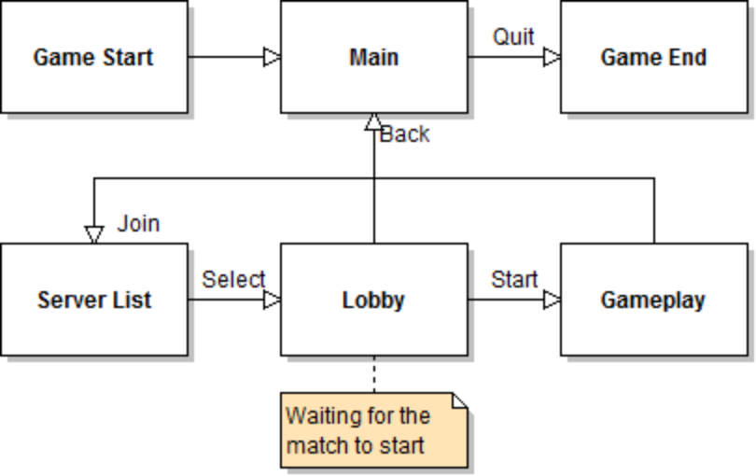

Technical details
This game is will be created for an assessment. This game, its prototypes and map editor are built using the most current version of the “codebase” static library. Due to this, it may be difficult to assess the coding aspects of this project as a whole during marking.

There will be four main scene objects in the game: the splash screen, the main menu, the server connection scene and the gameplay scene.

<MORE INFORMATION: How to find and connect to a server>
<MORE INFORMATION: How the networking protocol works>
<MORE INFORMATION: how the eight directions work correctly?>

Development Schedule
<PASTE HERE: Project Plan.xls>

Version 2
Components that didn’t make it into the final product are listed here for future expansion

- Different types of guns, collected from a new type of pickup.
- External Lua scripts for bot AIs, allowing for each bot to have a different algorithm, rather than just having different values in the same algorithm.

Post Mortem
<TODO>

<TODO LIST/NOTES>
Feature list for programming
Fill out the tagged sections
Replace the main picture

